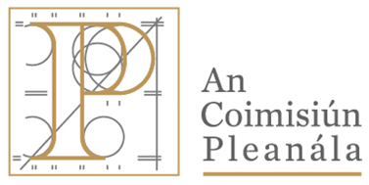 | Memorandum
 | ACP-323422-25
To: | Niall Haverty
From: | Lauren Griffin, Executive Officer
Re: | Proposed Development for N58 Strade River Bridge Rehabilitation Works
Date: | 12th November 2025
The Commission circulated submissions for comment to the local authority on the 6th day of October 2025, requesting a response no later than 17:30pm on 28th day of October 2025.

We have not received a response from the local authority to date, please advise if a further request for response should be sought.

Herewith for your consideration.

